DAY 1
Day 1 of my #100DaysOfCyberSecurity started by looking into the blue team to discover what it's all about.
The Blue Team stands as the defensive side of cybersecurity. It is mainly composed of SOC Teams and Insident Responders. They implement tools and techniques that protect/defend an organization's data, network or system.
Blue teamers perform the follow roles in an organization:
1. Monitoring and Detecting: Blue teams are constantly on the look for threats and vulnerabilities in systems and networks. They proactively utilize tools like SIEM(Security Incident and Event Management) systems and EDR(Endpoint Detection and Response) systems to scan, and monitor for activities and threats that could undermine the security of their organization.
2. Incident Response: Being the defensive end of cybersecurity, blue teamers counter threat actors by tackling and responding to security incidents and alerts. Once incidents are detected by Intrusion Detection Systems in place, blue teams mostly SOC analysts go through the alerts and logs to make clarifications, updates, patches and various remediations where necessary.
3. Digital Forensics: Blue teams undergo forensic analysis to uncover culprits behind security breaches and attacks. They analyze digital evidence artifacts, determine attacks that occured and who to be held responsible.
4. Policy Enforcement: They enforce security policies and controls on all members of the organization to ensure in depth adherence to policies and regulations.
5. Awareness: Blue teamers also conduct security training and awareness programs to enlighten employees on how to properly access organization infrastructure securely without imposing insider threats.

Next Up, I went through the NIST SP 800-61 which covered guidelines for Incident Handling.
Indident Handling/Response as it implies basically deals with the addressing and managing cybersecurity incidents and events. It involves detecting, analysing, containing, eradicating, and recovering from cyber attacks and various threats. NIST serves a stand industry guideline to perform incident response which it categorised under:
1. Preparation
2. Detection and Analysis
3. Containment, Eradication, and Recovery
4. Post Incident Activity

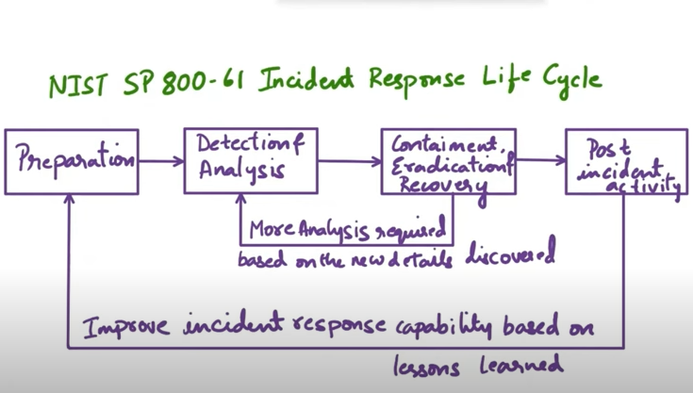
Study Resource:
1. LET'S Defend Website (https://letsdefend.io/blog/what-is-blue-team-in-cybersecurity)
2. Hackersploit on YouTube(https://youtu.be/kkjsQV64r14?si=TMIrEpUKhNrgIIlT).
3.CyberPlatter on YouTube(https://youtu.be/IRSQEO0koYY?si=atZEQ5xJmx_58xhp)
4. NIST Special Publication(https://nvlpubs.nist.gov/nistpubs/specialpublications/nist.sp.800-61r2.pdf)

